Summary of Session One: Cloud and Microsoft Azure 101
This session provides a comprehensive introduction to cloud computing concepts, focusing on Microsoft Azure’s services, cloud types, service models, and practical considerations for adopting and leveraging Azure.

Core Concepts and Cloud Types
- Private Cloud:
  - Entirely managed and hosted by an organization on-premises.
  - Full control over hardware, OS, applications, and management infrastructure.
  - Resources like virtual machines (VMs), containers, and databases are exposed internally.
  - Management layers enable self-service provisioning within the organization.
- Public Cloud:
  - Services provided by external providers over the Internet (or private connections).
  - Examples: Microsoft Azure, AWS, Google Cloud.
  - Users interact with a control plane abstracting physical infrastructure.
  - Offers diverse resources (VMs, AI services, databases) with rich governance, security, and scalability features.
  - Infrastructure is hidden; users provision resources declaratively via APIs, portals, or command line.
- Community Cloud:
  - Shared infrastructure among a group of organizations with common interests, e.g., government agencies.
- Hybrid Cloud:
  - Combination of on-premises and public cloud resources.
  - Enables seamless management through tools like Azure Arc and Azure Stack (Azure Local), extending Azure services on-premises.

Defining Cloud Computing (NIST Five Characteristics)
- On-Demand Self-Service:
Users can provision computing resources independently without human intervention, controlled by governance policies.
- Broad Network Access:
Services are accessible over the network via standard protocols, commonly Internet or private connectivity.
- Resource Pooling:
Providers pool resources to serve multiple tenants securely with strong isolation (multi-tenancy).
- Rapid Elasticity:
Resources can be elastically scaled up or down automatically to meet demand, resembling an “infinite” resource pool.
- Measured Service:
Usage is metered and billed based on consumption, supporting tagging and budget controls for cost visibility.

Cloud Service Models Explained Using a Pizza Analogy
- Infrastructure as a Service (IaaS):
  - Provider manages physical hardware, network, storage, and hypervisor.
  - User manages OS, middleware, runtime, applications, and data.
  - Example: VMs in Azure.
- Platform as a Service (PaaS):
  - Provider manages OS, middleware, runtime.
  - User focuses on applications and data only.
  - Examples: Azure App Service, Azure SQL Database (managed databases).
- Software as a Service (SaaS):
  - Provider manages everything except user data.
  - User only manages data classification, security policies, and usage.
  - Examples: Microsoft 365, Dynamics 365.
Key Insight: The higher the service level, the less responsibility for infrastructure and operations, often correlating with increased cost but reduced operational overhead.

Reasons to Use Public Cloud and Azure
- Shift from IT Infrastructure Management:
Organizations can focus on business needs rather than managing physical infrastructure.
- Cost Efficiency through Elasticity:
Scale resources dynamically to match workload demand (e.g., pizza shop analogy with Friday/Saturday nights and Super Bowl spikes). Pay only for resources used.
- Flexibility and Agility:
Ability to change resource types, regions, and services on demand without long-term commitments.
- Disaster Recovery:
Cloud allows cost-effective DR by running failover environments only when needed.
- Global Reach:
Deploy services closer to customers worldwide using Azure regions and features like Azure Front Door.
- Modernization Catalyst:
Encourages adoption of containers, serverless computing, AI, and managed services.
- Operational Expense vs. Capital Expense:
Cloud converts large upfront investments into operational costs, improving financial flexibility.
- Governance and Security:
Azure provides advanced policy controls, monitoring, and security features.

Adoption Patterns and Use Cases
- Start small with less critical workloads such as development and testing.
- Gradually move production workloads as confidence and skills grow.
- Use cloud for predictable or unpredictable bursting scenarios (e.g., retail spikes, news events).
- Hybrid deployments for latency-sensitive or legacy applications remaining on-premises.

Azure’s Extensive Service Offerings
- Compute: Windows/Linux VMs, VM scale sets, containers, Azure Kubernetes Service (AKS).
- Storage and Databases: Azure Blob Storage, Cosmos DB, Azure SQL, managed PostgreSQL.
- AI and Machine Learning: Bot services, AI search, video indexing, OpenAI integration.
- Networking: Virtual networks, firewalls, Azure Front Door for global content delivery.
- Security and Governance: Identity management (Azure AD), policies, budget controls, multi-factor authentication.
- Developer Tools and DevOps: Integrated monitoring, CI/CD pipelines, infrastructure as code.

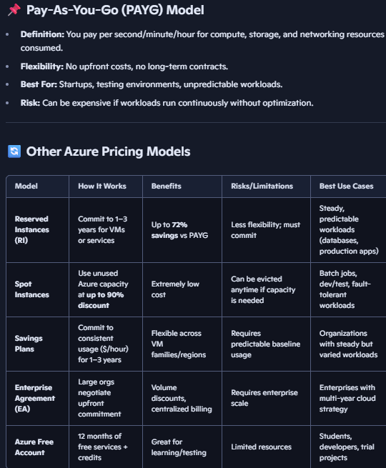
Getting Started with Azure
- Free Trial:
  - $200 credit for one month to explore nearly all Azure services.
  - Certain services free for 12 months or always free, such as Cosmos DB, AI document intelligence.
- Subscriptions and Licensing:
  - Pay-as-you-go model suits individuals and small organizations.
  - Enterprise Agreement (EA) supports multiple subscriptions with role-based access and organizational management.
  - Visual Studio subscribers receive monthly Azure credits.
- Resource Management:
  - Use subscriptions, resource groups, management groups, and tags for organization, billing, and governance.
  - Be mindful of service limits and quotas; soft limits can be increased via support requests.

Reliability and Resiliency in Azure
- Shift from hardware-centric reliability (on-premises) to software-defined reliability in cloud architectures.
- Azure uses distributed infrastructure with independent fault domains, update domains, and availability zones.
- Services run multiple instances across isolated hardware to avoid single points of failure.
- Azure data centers have robust physical infrastructure (power, cooling, security) ensuring high availability.
- Applications must be architected for distributed, fault-tolerant operation to leverage cloud resiliency fully.

Why Choose Azure? (Market Position and Vision)
- Recognized as a leader in Gartner’s Magic Quadrant for cloud infrastructure and platform services.
- Strong hybrid cloud capabilities via Azure Arc and Azure Stack.
- Continuous innovation with frequent incremental updates (cloud cadence).
- Comprehensive global footprint and broad set of integrated services.
- Emphasis on integration, security, and governance over chasing isolated features.
- Competes primarily with AWS and Google Cloud as major global cloud providers.

Key Takeaways
- Cloud computing is about shifting responsibility to focus on business value, not managing infrastructure.
- Azure offers a broad, mature ecosystem suitable for enterprises with hybrid needs.
- Elasticity and pay-per-use models drive cost efficiency and agility.
- Cloud adoption is a journey starting with low-risk workloads and scaling progressively.
- Reliability is achieved through software architecture and distributed infrastructure, not just hardware redundancy.
- Governance, security, and operational management are integral to successful cloud usage.
- Azure’s leadership and innovation make it a strong choice for current and future cloud strategies.

